**Terna Engineering College**

**Computer Engineering Department**

**Program: Sem VI**

**Course: Software Engineering Lab**

**LAB Manual**

**PART A**

(PART A: TO BE REFERRED BY STUDENTS)

**Experiment No.10**

**A.1 Aim:**

Design User Interface for the selected mini-project.

**A.2 Prerequisite:**

knowledge of Software Design and different types of Design.

**A.3 Outcome:**

After the successful completion of this experiment students, Student will be able to Design User Interfaces for selected mini-project by selecting appropriate tools.

**A.4 Theory:**

**Design:** Translating requirements into blueprints for the construction of software.

* **Different types of Design:**
  + **Data Design**
  + **Architecture Design**
  + **Interface Design**
  + **Network Design**
  + **Database Design**
  + **Procedural Design**
  + **Presentation Design**

**User Interface:** Collection of different techniques and tools to interact with something. Or it is a communication medium through which user can communicate with the system.

* **Types of Interfaces:**
* Command-line Interface: Interaction with the help of commands
* Graphical User Interface (GUI): Interaction with the help of Graphics like;
* Audio
* Video
* Icons
* Menus
* Windows
* **Steps of User Interface Design**
* Functional requirement gathering
* User Analysis
* Mapping of the requirement into interfaces
* Design User Interfaces
* Implement user Interface
* Perform Usability Testing
* **Characteristics of User Interfaces**
* Aesthetically Pleasant
* Consistent
* Responsiveness
* Efficient
* Task-Oriented
* Control
* Etc.
* **User Interface Design Process:**

The user interface design process is divided into various phases.

1. **Functionality Requirement gathering:** identify functional requirements expected by the users. After analyzing the requirements a decision is made on how to incorporate these requirements into the interface and what functionality to include i.e. requirements are mapped into interfaces
2. **User Analysis: This** refersto analyzing potential users of the system either through discussions with people who work with the users or with potential users themselves. Ask questions regarding;

* What does the user want?
* How the user is going to use the system
* What are the technical abilities of the user?

1. **Information Architecture:** identify information architecture of the system i.e. how the information flow from one page to another page, that is to show the hierarchy of pages.
2. **Design User Interface**:
3. **Usability Testing**: Perform usability testing of the user interfaces for any usability defects.

**PART B**

(PART B: TO BE COMPLETED BY STUDENTS)

***(Students must submit the soft copy as per the following segments within two hours of the practical. The soft copy must be uploaded on the Blackboard or emailed to the concerned lab in charge faculties at the end of the practical in case there is no Blackboard access available)***

|  |  |
| --- | --- |
| **Roll No.** 50 | **Name:** AMEY THAKUR |
| **Class:** Comps TE B | **Batch:** B3 |
| **Date of Experiment:** 31/03/2021 | **Date of Submission:** 31/03/2021 |
| **Grade:** |  |

**B.1 Add the Snapshots of User Interfaces and Database Design of your selected mini project**

**Front-end**

* **Index Page**

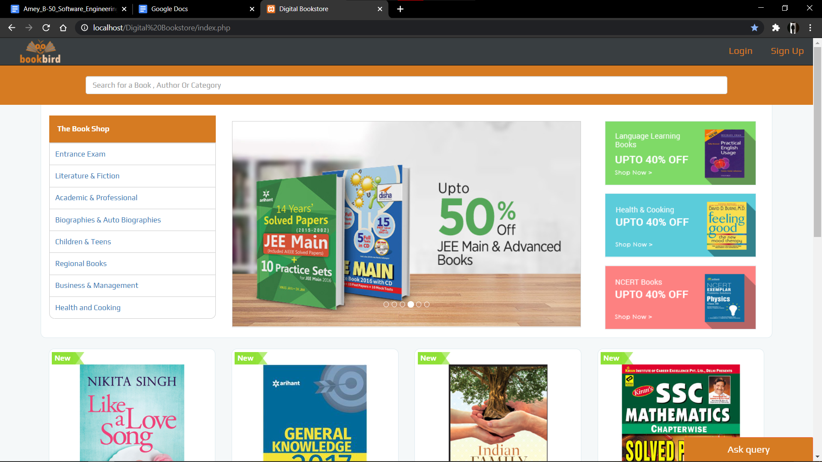

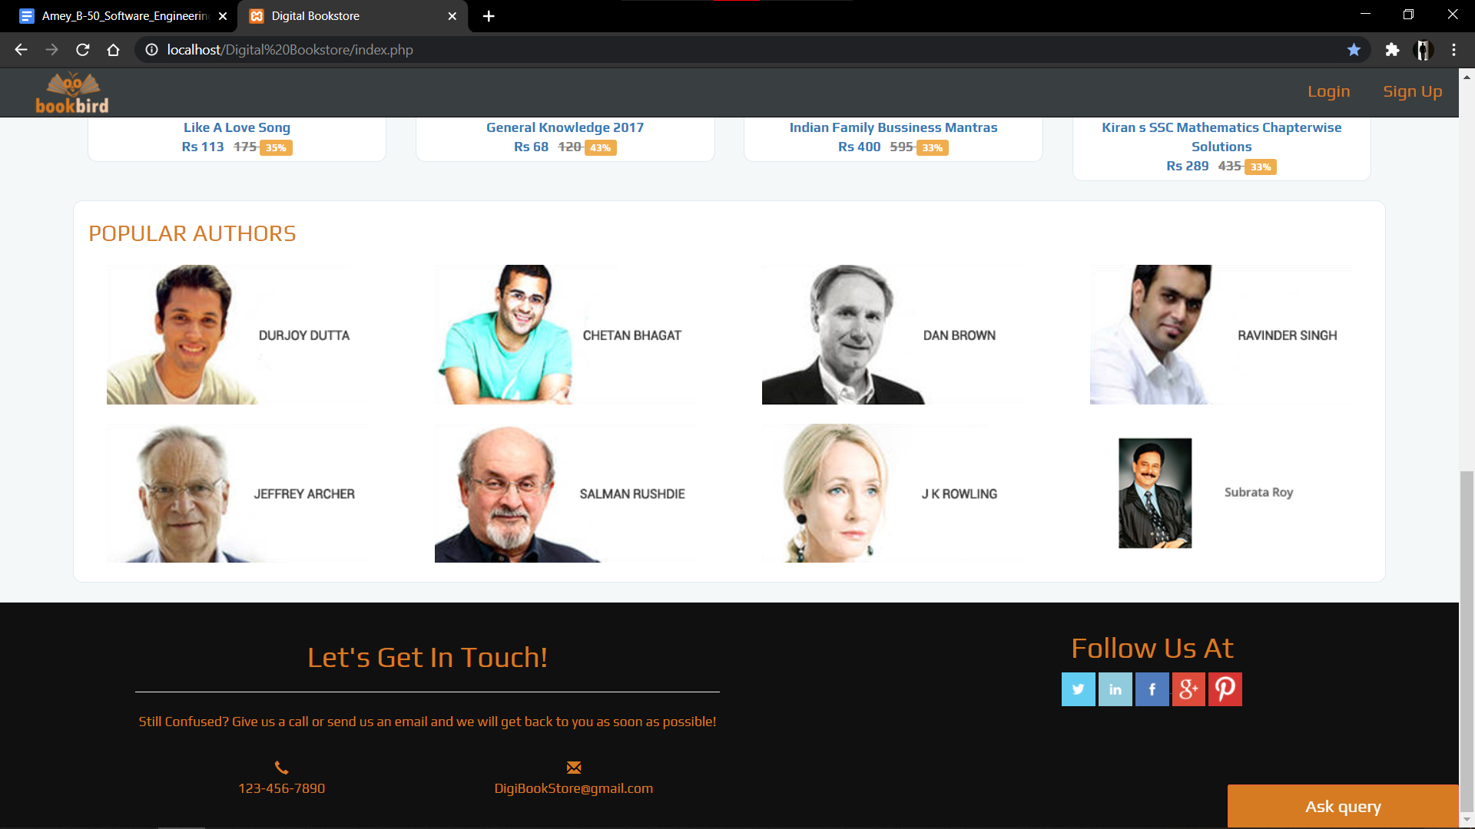

* **Member Registration Form**

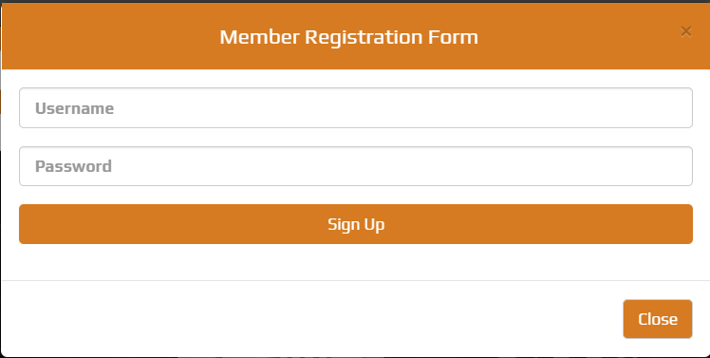

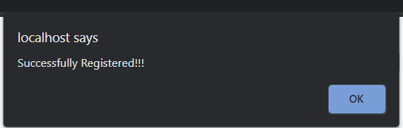

* **Login Form**

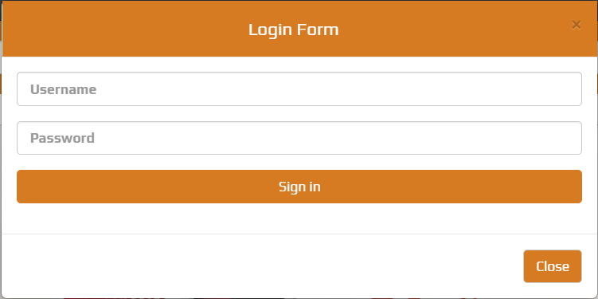

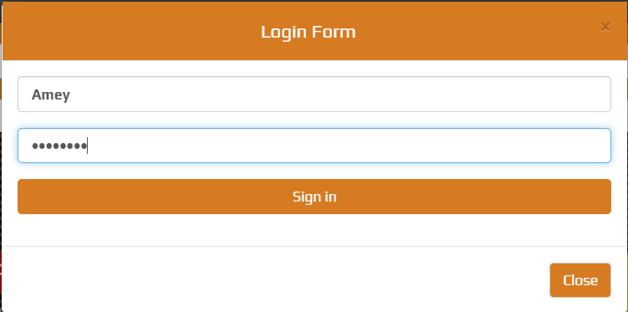

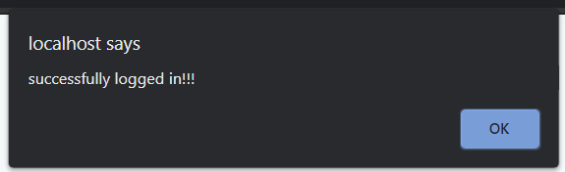

* **Home Page**

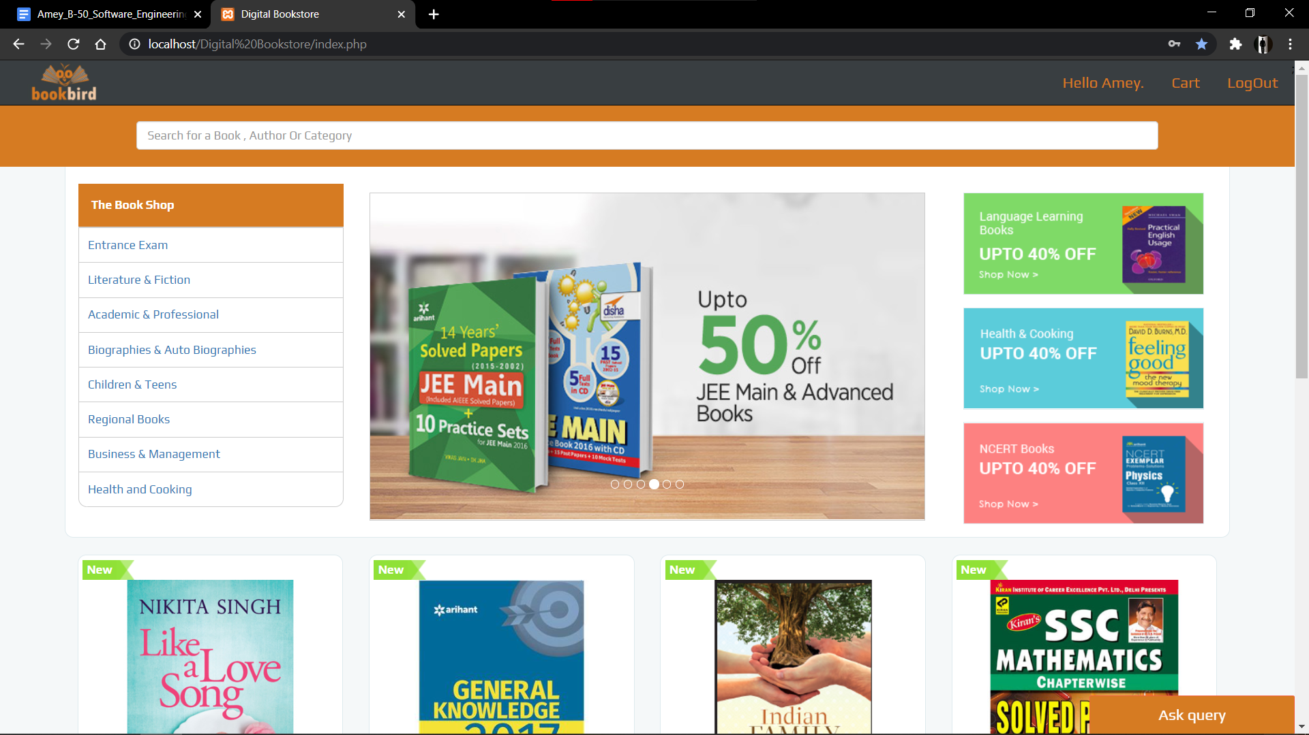

* **The Book Shop (Book Genres)**

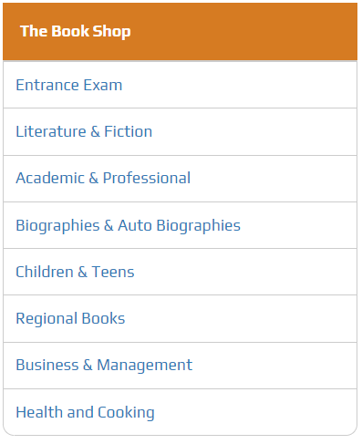

* **Sort By**

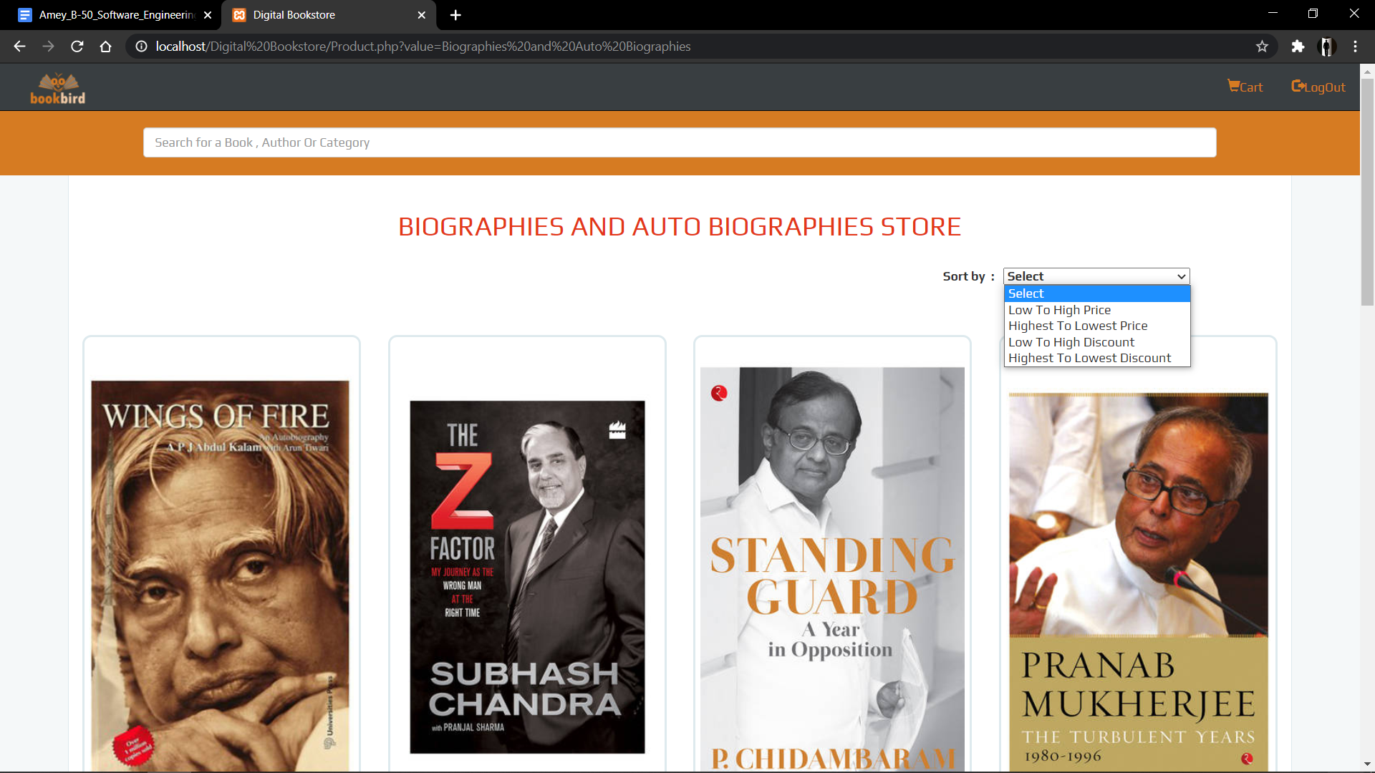

* **Search Bar**



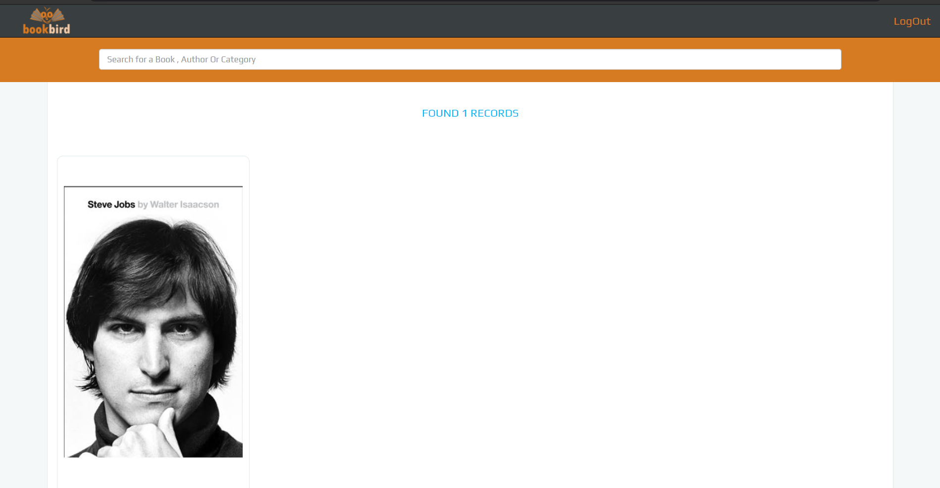

* **Add to Cart**

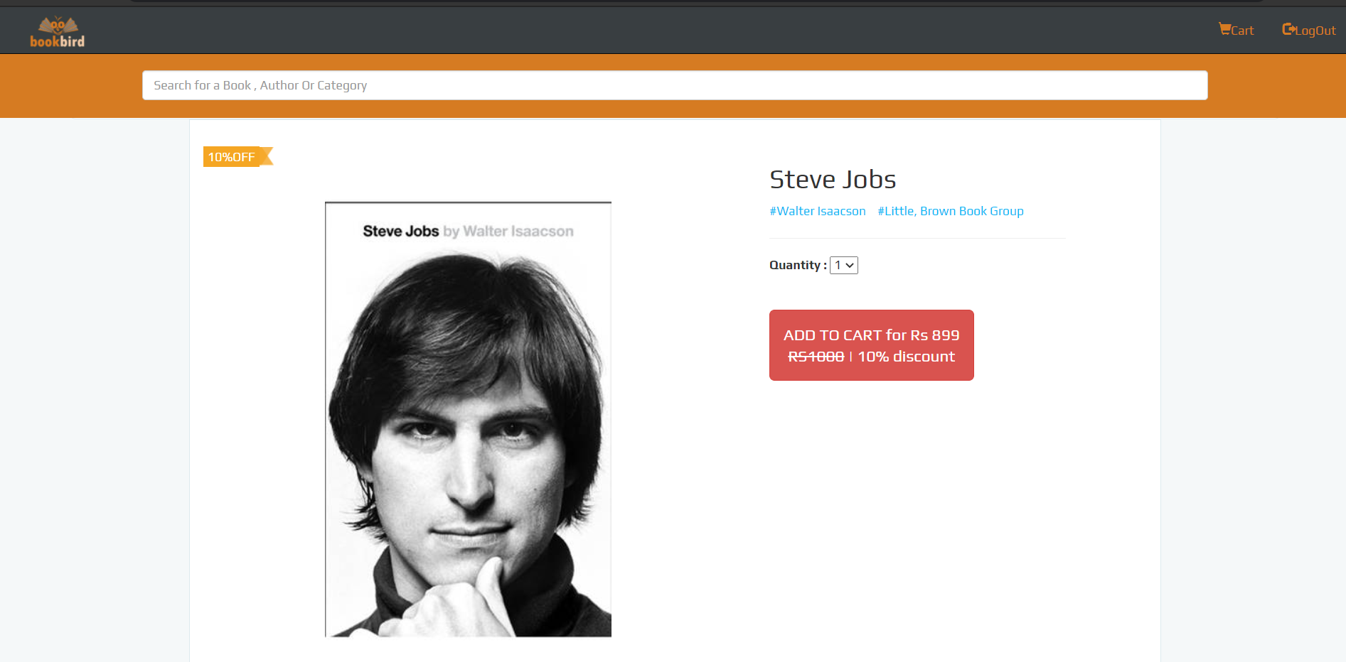

* **Book Description**

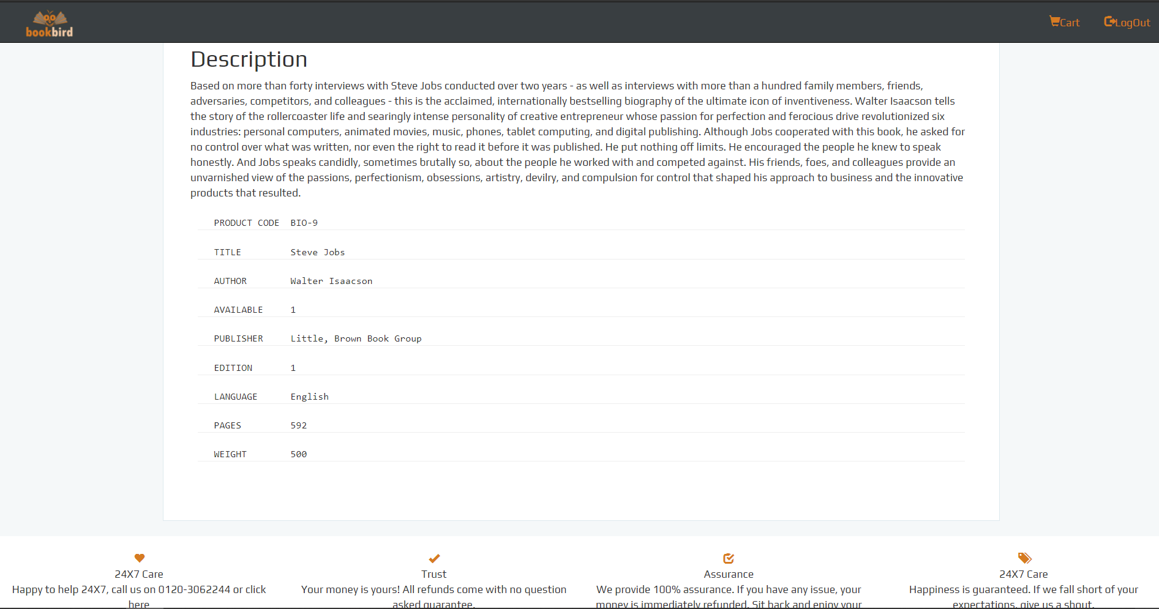

* **Database Connection**

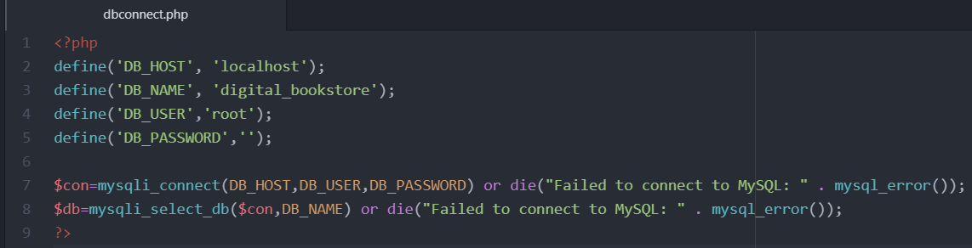

* **Cart (Empty)**

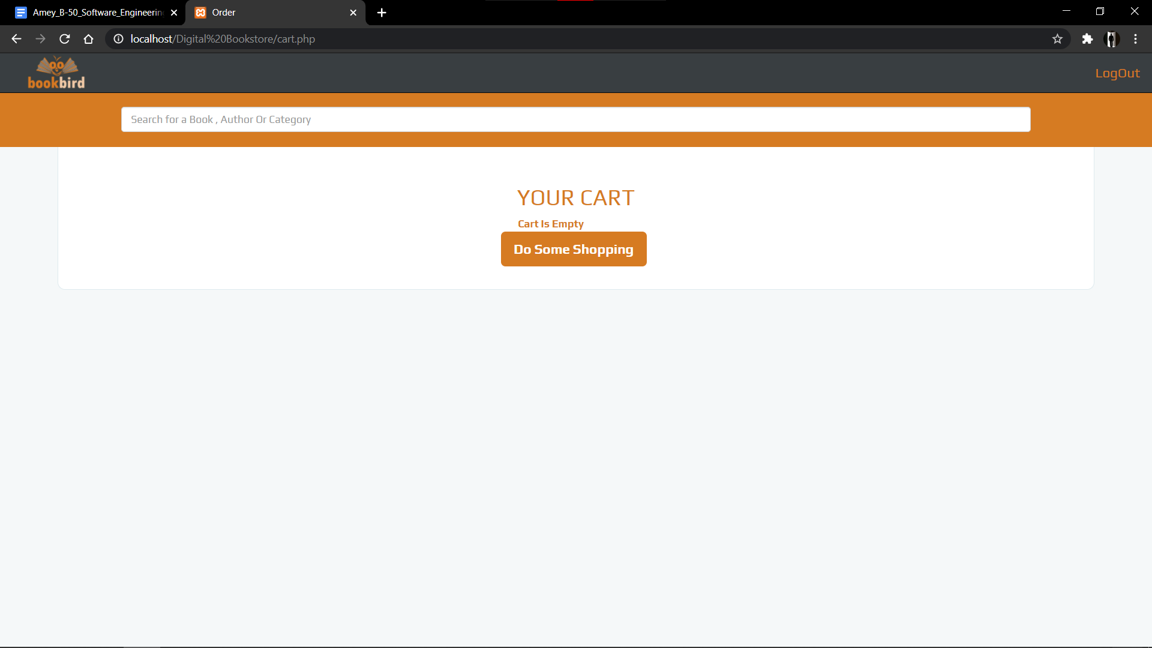

* **Cart**

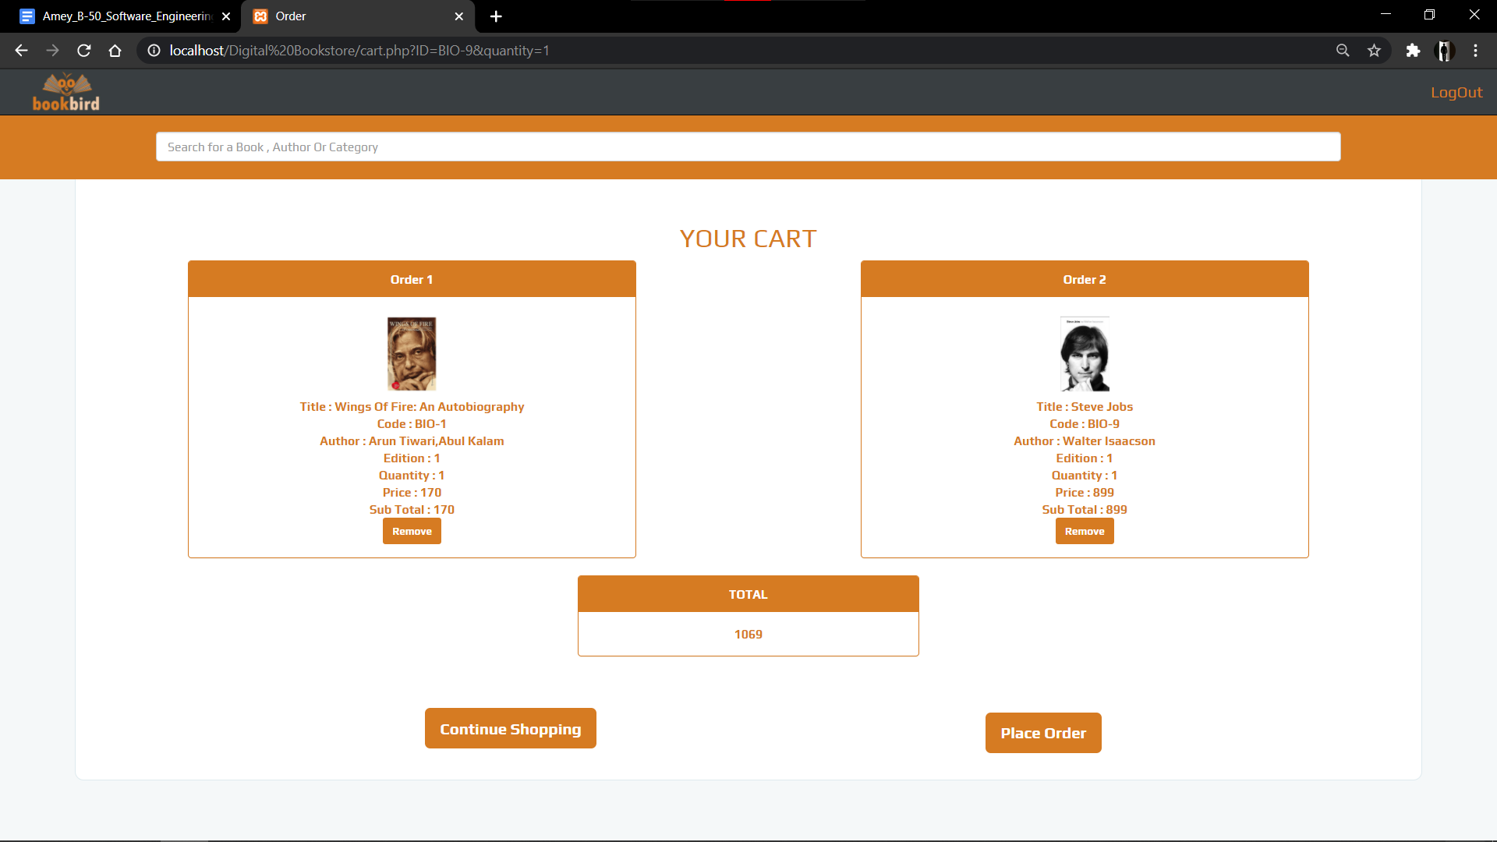

* **Place Order**

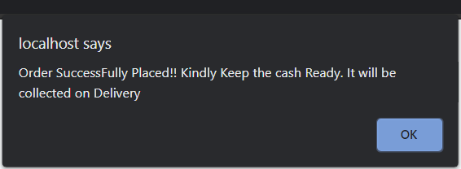

* **Ask Query**

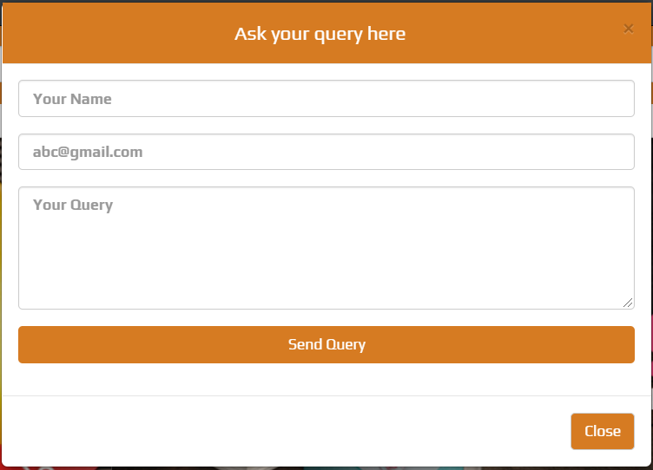

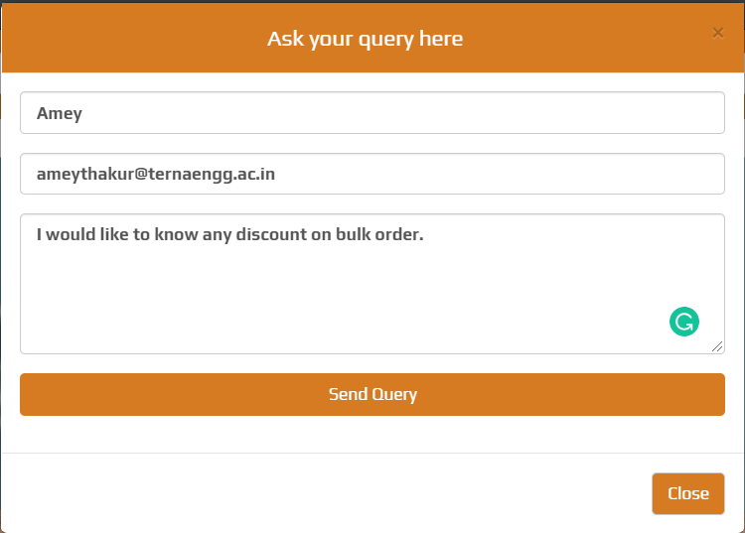

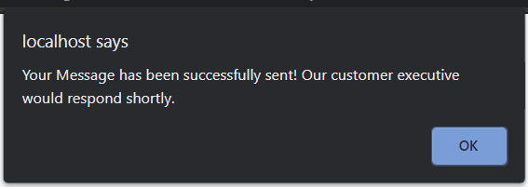

* **Logout**

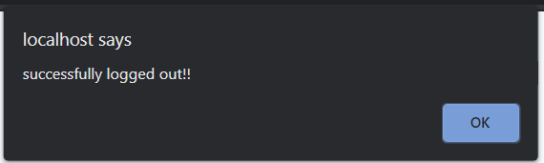

**Back-end**

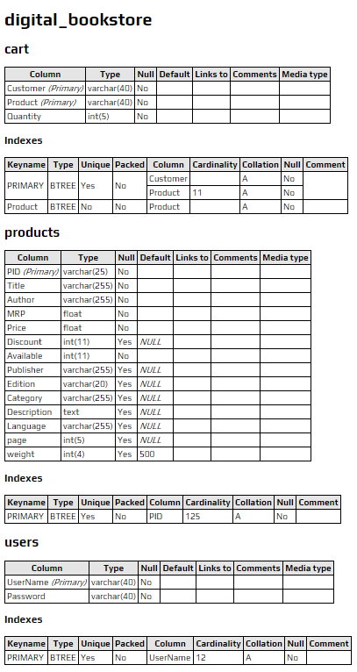

1. Server: 127.0.0.1
2. Database: digital_bookstore

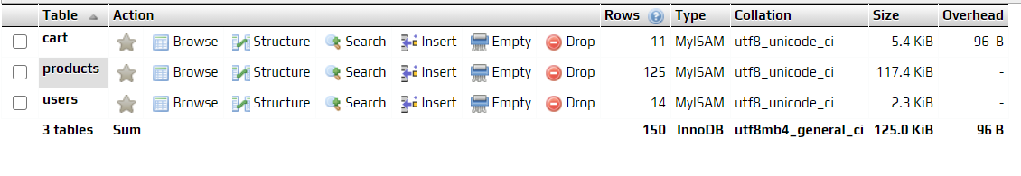

1. Server: 127.0.0.1
2. Database: digital_bookstore
3. Table: cart

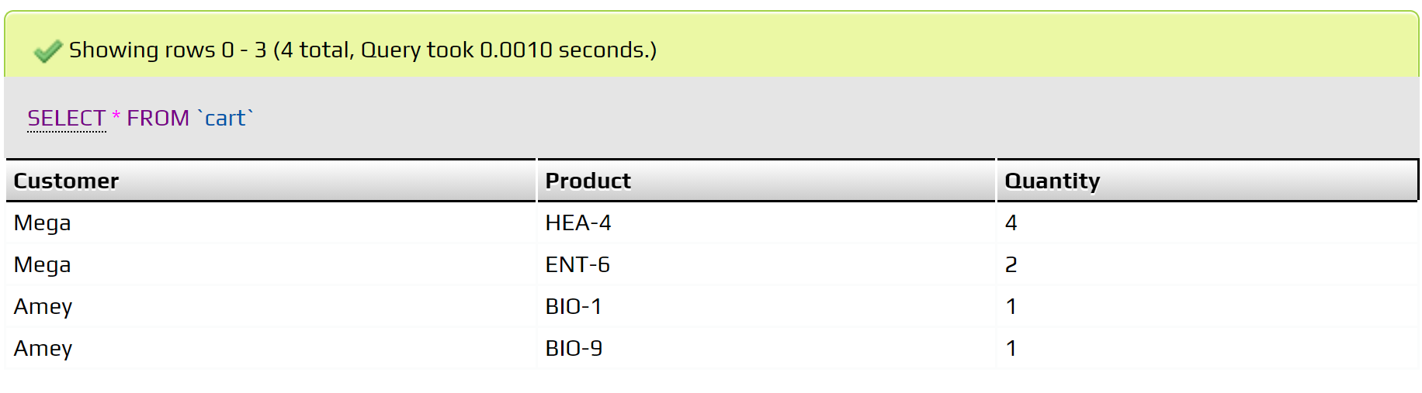

1. Server: 127.0.0.1
2. Database: digital_bookstore
3. Table: products

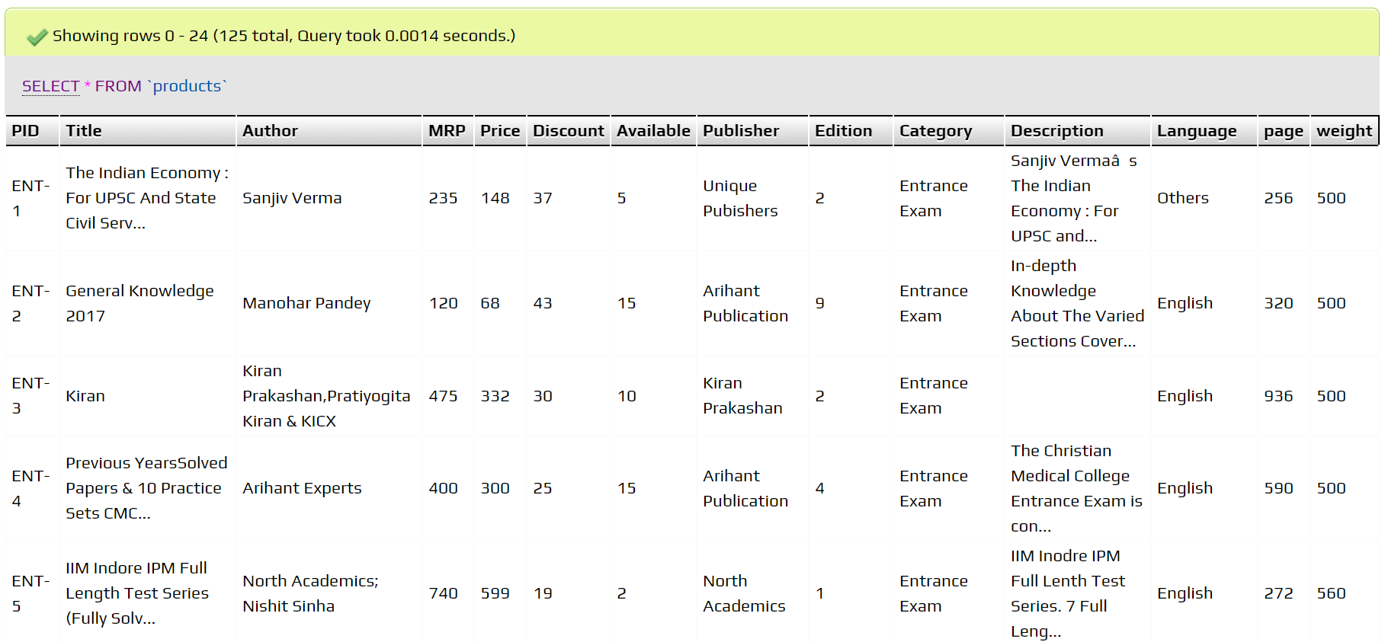

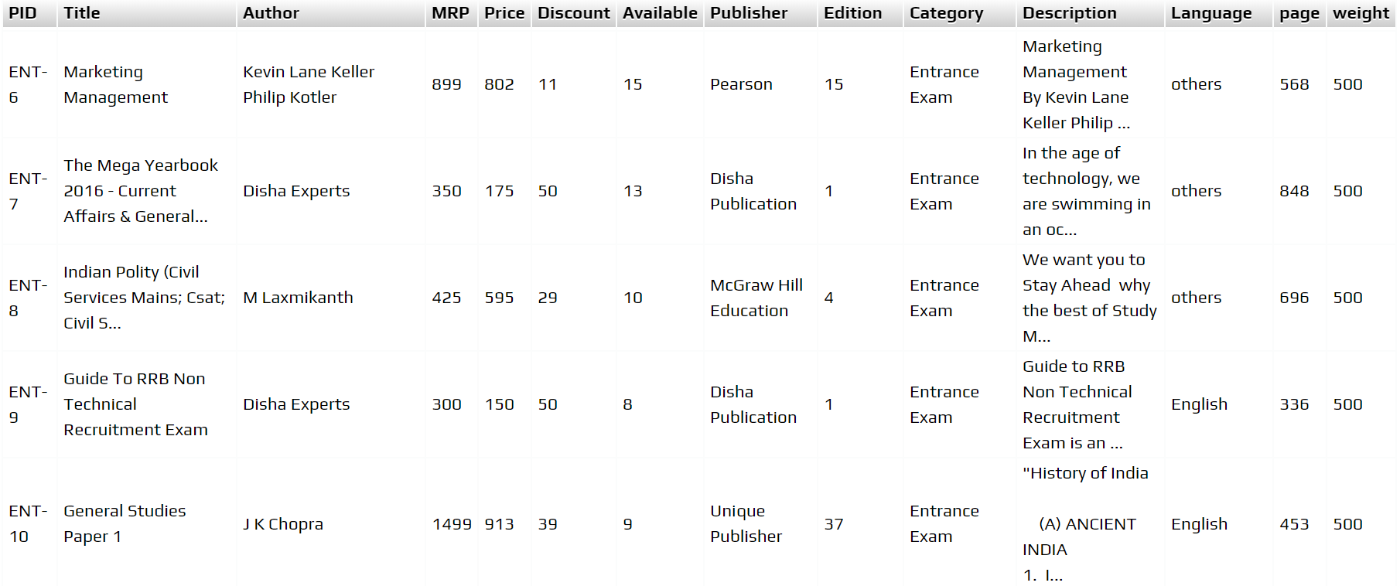

1. Server: 127.0.0.1
2. Database: digital_bookstore
3. Table: users

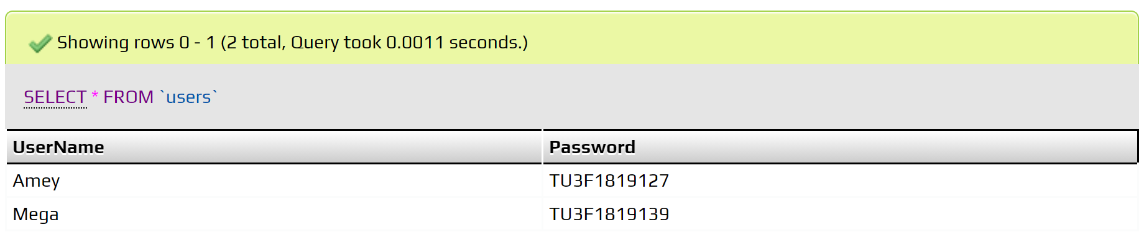

**B.2 Conclusion:**

*(****Students must write the conclusion)***

We built the User Interface of our Digital Bookstore website with a database on the XAMPP web server. We also learned to design a database for the same.